This Technical Bulletin provides instructions for updating mBSP ECUs in response to SPN 629 FMI 11 and SPN 523000 FMI 2 error codes on vehicles equipped with part numbers:

400 864 815 0 | 400 864 821 0 | 400 864 825 0
400 864 816 0 | 400 864 822 0 | 400 864 826 0
400 864 817 0 | 400 864 823 0 | 400 864 827 0
400 864 818 0 | 400 864 824 0 | 400 864 828 0
400 867 119 0 | 400 867 128 0 | 400 867 130 0
400 867 120 0 | 400 867 129 0 | 400 867 131 0
400 867 121 0 | 400 867 125 0 | 400 867 132 0
400 867 122 0 | 400 867 126 0 | 400 867 133 0

*Note* ECUs with error codes SPN 520272 FMI 13 should be updated with aftermarket programming before performing the Flash Tool update.

Hazard Alert Messages

Read and observe all Warning and Caution hazard alert messages in this publication. They provide information that can help prevent serious personal injury, damage to components, or both.

WARNING
To prevent serious eye injury, always wear safe eye protection when you perform vehicle maintenance or service.

Park the vehicle on a level surface. Block the wheels to prevent the vehicle from moving. Support the vehicle with safety stands. Do not work under a vehicle supported only by jacks. Jacks can slip and fall over. Serious personal injury and damage to components can results.

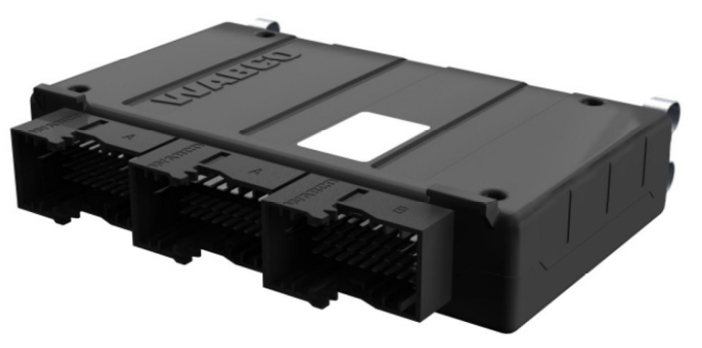

How to obtain additional maintenance and service information

If you have any questions regarding the material covered in this bulletin, or for information about the WABCO product line, please contact the WABCO Customer Service Center 855-228-3203 or visit our website https://www.wabco-auto.com.

This procedure consists of several different steps, please review the following instruction carefully first before proceeding:

Tools/Software Required

- Nexiq RP1210 Communications Adaptor
- mBSP Flash Tool (en) V1.30
- WABCO Toolbox

*Note* The file extension name must be .EXE Administrative rights may be required to download and use this file.

Flashing Process
Follow these steps:
- Confirm the ABS ECU P/N is one of the following:
400 864 815 0 | 400 864 821 0 | 400 864 825 0
400 864 816 0 | 400 864 822 0 | 400 864 826 0
400 864 817 0 | 400 864 823 0 | 400 864 827 0
400 864 818 0 | 400 864 824 0 | 400 864 828 0
400 867 119 0 | 400 867 128 0 | 400 867 130 0
400 867 120 0 | 400 867 129 0 | 400 867 131 0
400 867 121 0 | 400 867 125 0 | 400 867 132 0
400 867 122 0 | 400 867 126 0 | 400 867 133 0

- Download the mBSP Flash Tool from: mBSP Flash Tool Downloads (dtnaecomponents.com)

- Verify VIN compatibility using the “Flash Tool Compatibility Tracker” document. If VIN is compatible proceed to step 4.

- Install the mBSP Flash Tool by running the downloaded executable (I.E. mbspflashtool300en130.EXE).

- Apply the parking brake. Turn the ignition switch to the ON position.

- Connect a Nexiq RP1210 adaptor to the vehicle’s Deutsch 9 Pin Connector with mBSP Flash Tool Software CLOSED. Ensure no other diagnostic program is running (ToolBox, Diagnostic Link, etc.).

- Double-Click the mBSP Flash Tool shortcut titled “mBSP Flash Tool (en) V1.30” to launch the software.

- Click “Yes” to accept the warning.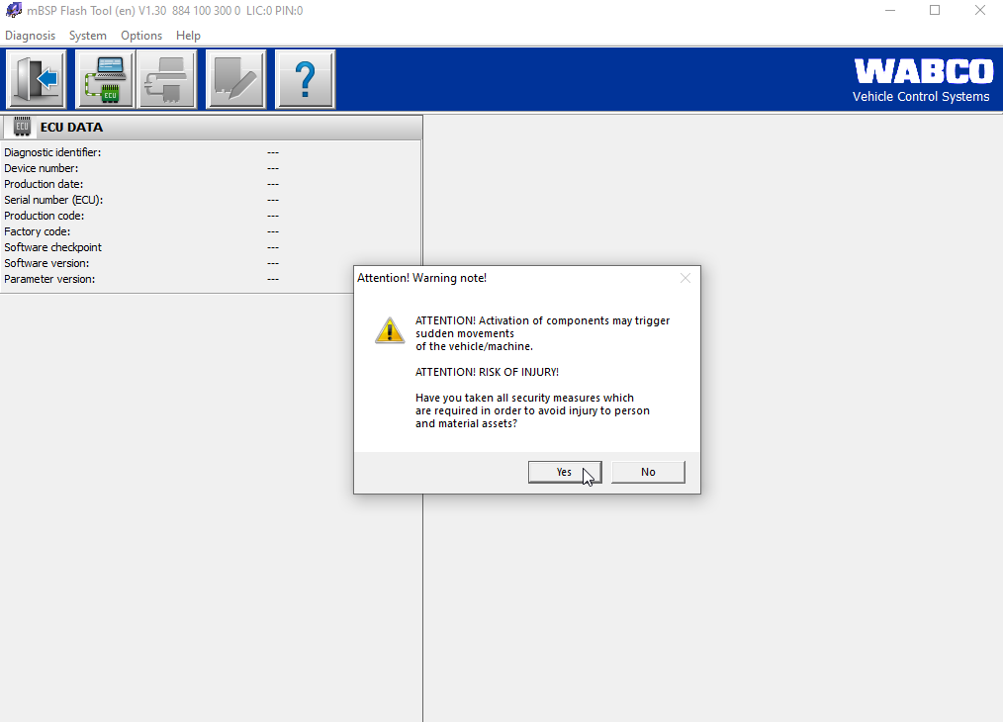

- If the ECU does not automatically connect, select “Initialize ECU and switch to diagnostic mode”. 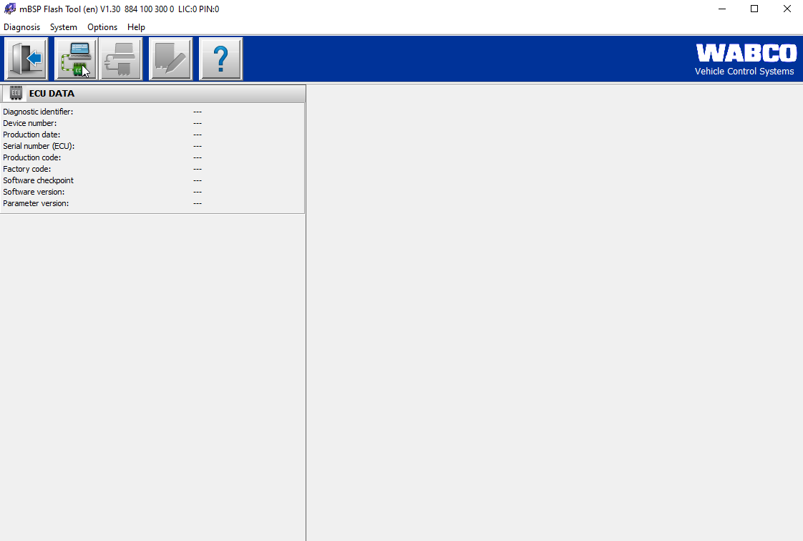

- Click “ECU software update” to begin the ECU update.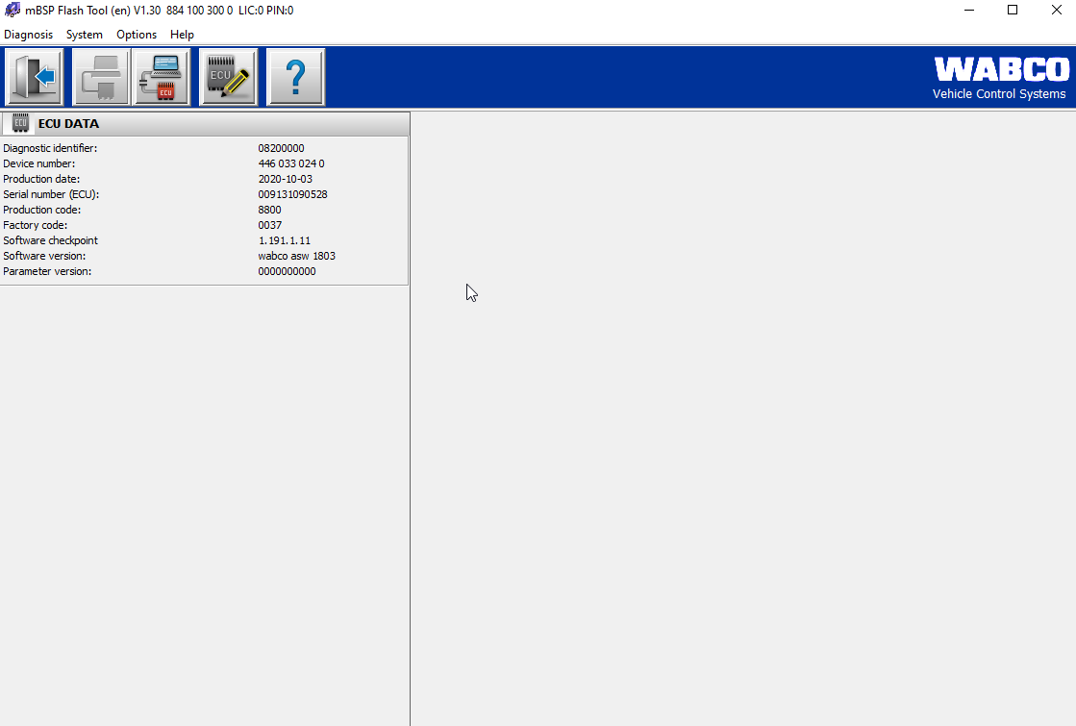

- Select “Write to ECU” and the ECU will begin to be updated.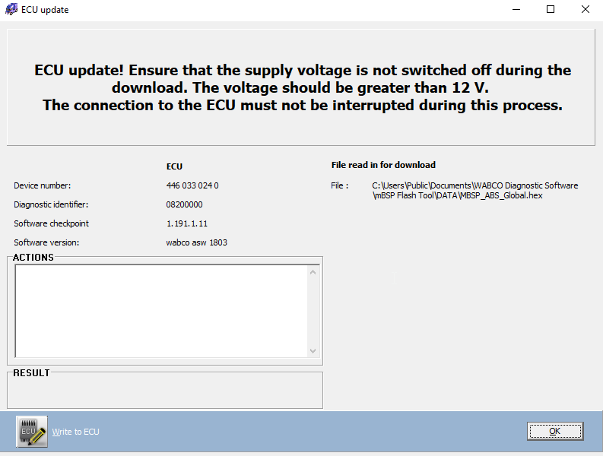

*Note* This process may take several minutes. Do NOT disconnect, turn key off, or allow PC to go to sleep
during this process.

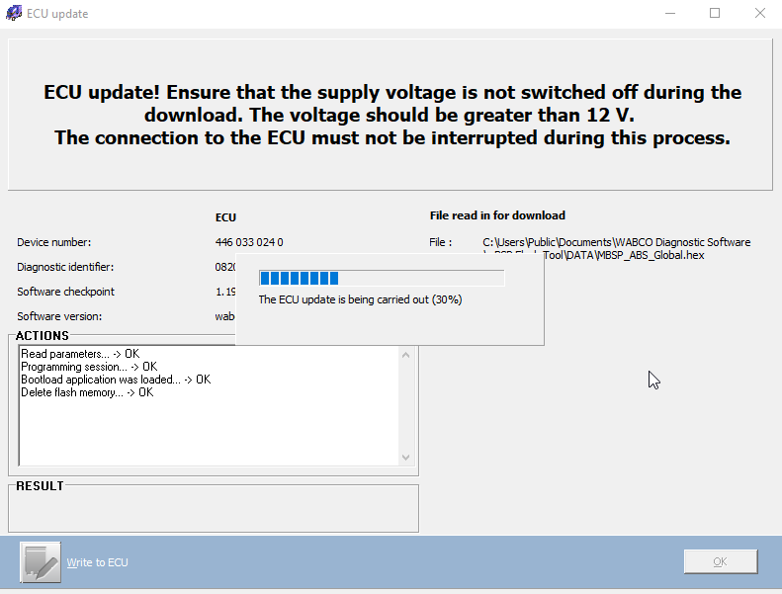

- Once the ECU update has been completed some ECU errors may be present. *Note* ESC Calibration will be required after the flashing process is completed. 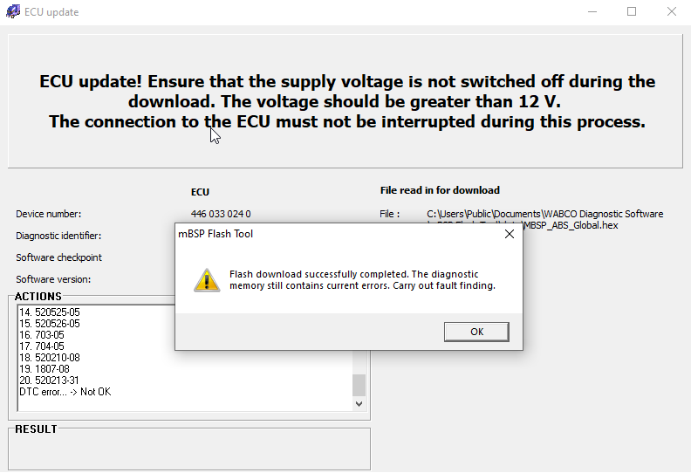

- Save a Parameter file from the ECU as proof the parameter update was completed successfully and add to the Vehicle Repair Order. This can be done in WABCO Toolbox. Launch the Toolbox software and select “Pneumatic ABS/ST Hydr J1939”.
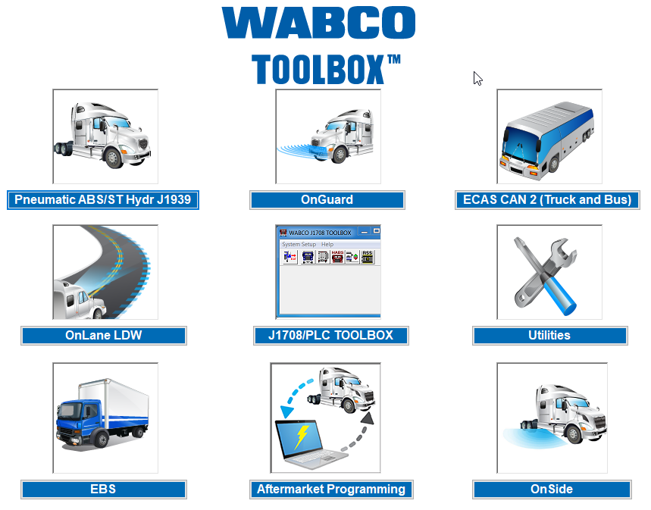
- Proceed to options and select “Save Parameters to File”. 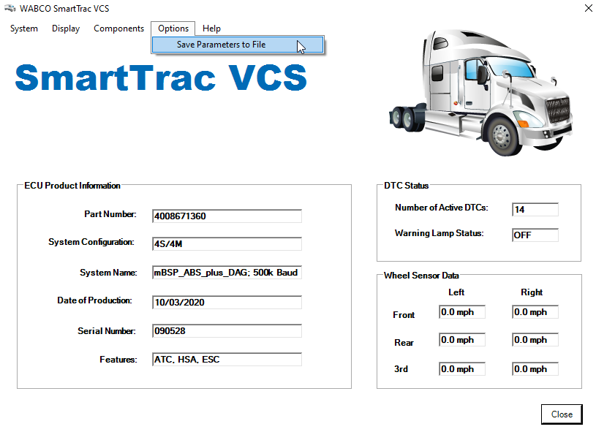

- The ECU update is now completed.
*Note* The mBSP Flash Tool will change the ECU part number internally to the following:
Original P/N |  | New P/N |  | Original P/N |  | New P/N |  | Original P/N |  | New P/N
400 864 815 0 | >> | 400 864 831 0 |  | 400 864 821 0 | >> | 400 864 831 0 |  | 400 864 825 0 | >> | 400 864 831 0
400 864 816 0 | >> | 400 864 832 0 |  | 400 864 822 0 | >> | 400 864 832 0 |  | 400 864 826 0 | >> | 400 864 832 0
400 864 817 0 | >> | 400 864 833 0 |  | 400 864 823 0 | >> | 400 864 833 0 |  | 400 864 827 0 | >> | 400 864 833 0
400 864 818 0 | >> | 400 864 834 0 |  | 400 864 824 0 | >> | 400 864 834 0 |  | 400 864 828 0 | >> | 400 864 834 0
400 867 119 0 | >> | 400 867 135 0 |  | 400 867 128 0 | >> | 400 867 135 0 |  | 400 867 130 0 | >> | 400 867 135 0
400 867 120 0 | >> | 400 867 136 0 |  | 400 867 129 0 | >> | 400 867 136 0 |  | 400 867 131 0 | >> | 400 867 136 0
400 867 121 0 | >> | 400 867 137 0 |  | 400 867 125 0 | >> | 400 867 137 0 |  | 400 867 132 0 | >> | 400 867 137 0
400 867 122 0 | >> | 400 867 138 0 |  | 400 867 126 0 | >> | 400 867 138 0 |  | 400 867 133 0 | >> | 400 867 138 0

- Complete new EOL (end of line) process for the ABS.

- Verify no faults are present and the ABS ECU part numbers have been updated.

