On Windows 10, Make Sure No Other Programs Are Running

Note: The programs / applications running on Windows 10 are shown on the Windows Task Bar, which is usually located at the bottom of the screen, and is the bar that the Windows Start Menu is accessed from:

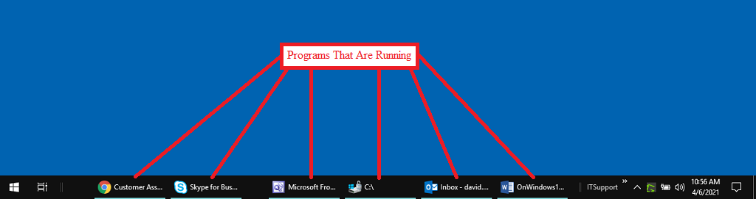

To close a running program...
1) Right-click on the program on the Windows task bar and then select ‘Close window’ from the pop-up menu:

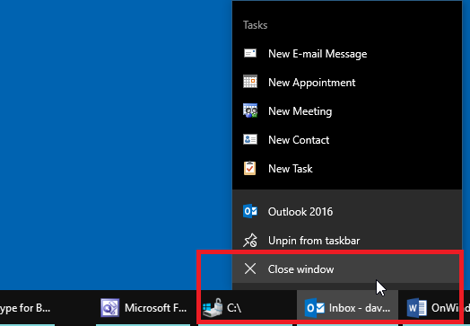

* The selected program will be closed.

2) Repeat step #1 until there are no more programs shown on the Windows task bar:

