How To Make Sure Your Windows 10 Computer Is Not Connected To The Internet

1) Unplug any network (Ethernet) cables, if any, that are plugged into your computer.
2) Click on the Windows Start Menu, type ‘wireless’ and then click ‘Open’ on the right hand side of the menu beneath ‘Turn wireless devices on or off’:

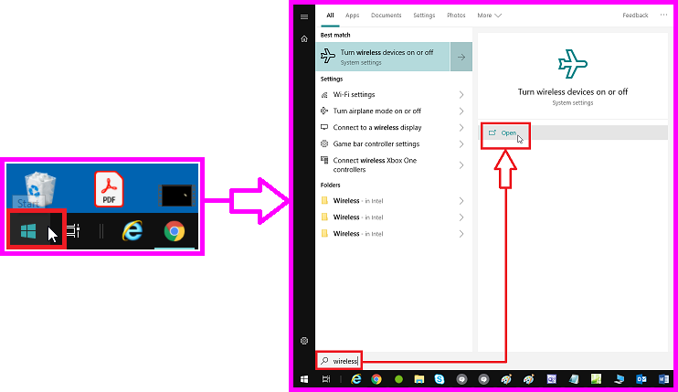

3) At the wireless devices ‘Settings’ window, click on the ‘wi-fi’ slider in the ‘Wireless Devices’ section and, while still clicking on the slider, drag the slider to the left:

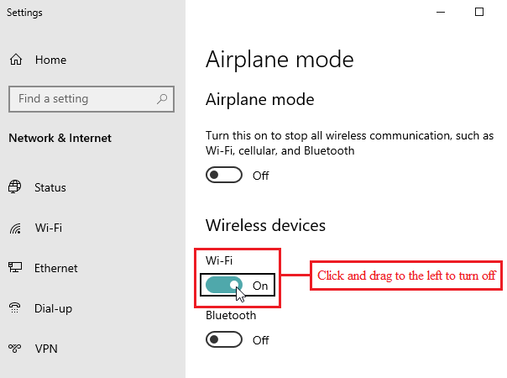

* The wireless connection will now be off:

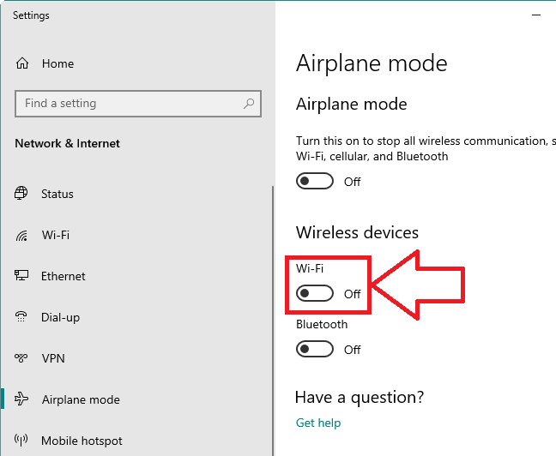

* Your connection to the Internet, hardwired (Ethernet) and wireless, will now be disconnection.

