How To Install The mBSP Flash Tool

*Note: Steps 1 through 3 of these instructions were written from the perspective of using Google Chrome as the web browser. Other web browsers (I.E. Internet Explorer, Microsoft Edge, etc.) will look similar.

Within your web browser...
1) Browse to the following address:

https://www.dtnaecomponents.com/Downloads/mBSPFlashTool/mBSPFlashToolDownloads.htm

2) Click on the ‘Download mBSP Flash Tool’ link:

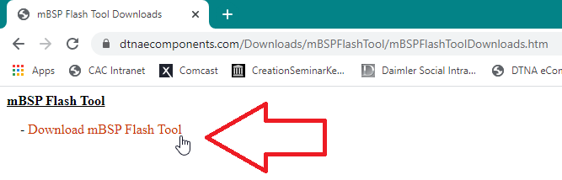

3) Choose the options to save the ‘mbspflashtool300en130.EXE’ file to a location on your local hard drive (I.E. C:\Temp):

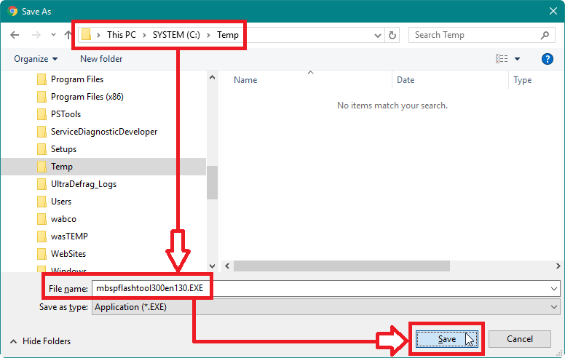

4) After the ‘mbspflashtool300en130.EXE’ file has downloaded, select the option to open or run the file:

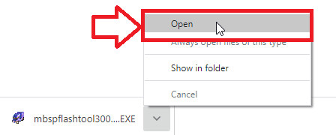

5) At the ‘WinAce v2.5 Self-Extractor’ window, click <EXTRACT>:

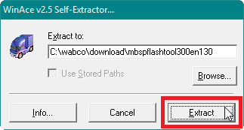

* The program files will be extracted to your local hard drive:

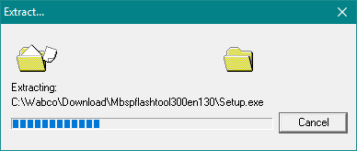

6) At the ‘Confirmation’ dialog box, click <YES>:

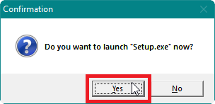

7) At the ‘Select Setup Language’ dialog box, click <OK>:

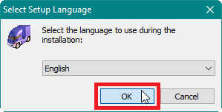

8) At the ‘Welcome to the mBSP Flash Tool Setup Wizard’ window, click <NEXT>:

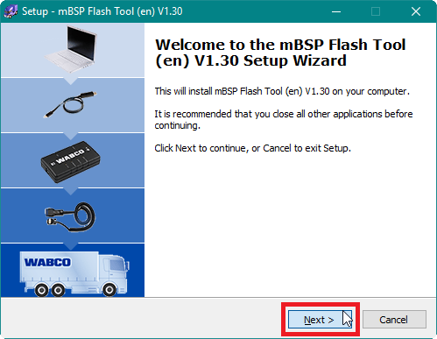

9) At the ‘License Agreement’ window, select ‘I accept the agreement’ and then click <NEXT>:

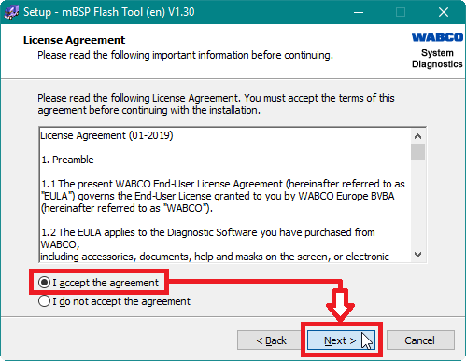

10) At the ‘Information’ window, click <NEXT>:

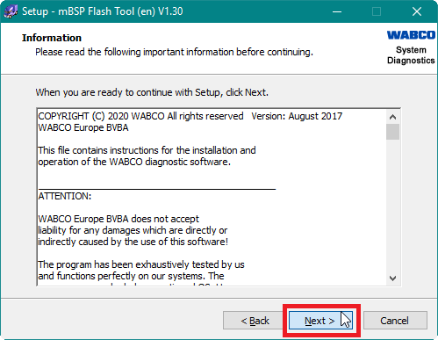

11) At the ‘Select Destination Location’ window, click <NEXT>:

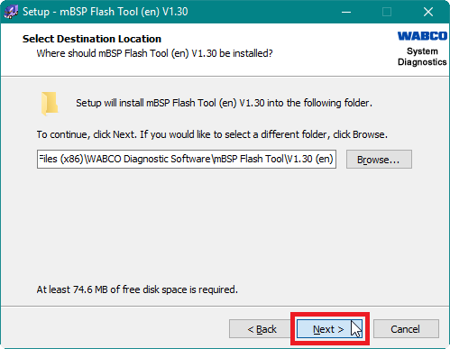

12) At the ‘Select Start Menu Folder’ window, click <NEXT>:

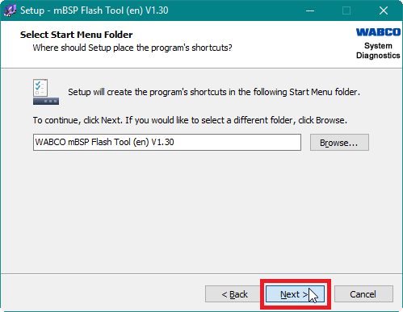

13) At the ‘Select Additional Tasks’ window, select ‘Create a desktop shortcut’ and then click <NEXT>:

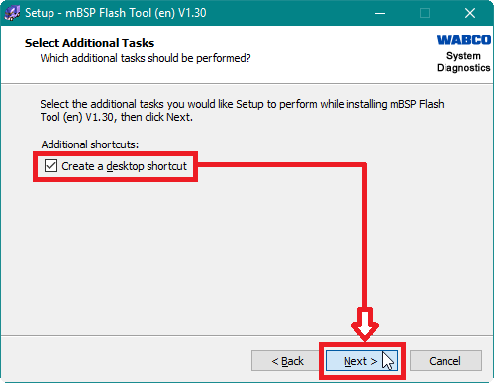

14) At the ‘Ready to Install’ window, click <INSTALL>:

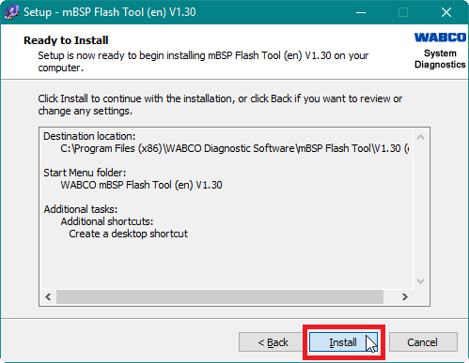

15) If you receive a window like the one below, regarding applications using files that are needed by the setup program, select ‘Automatically close the applications’ and then click <NEXT>:

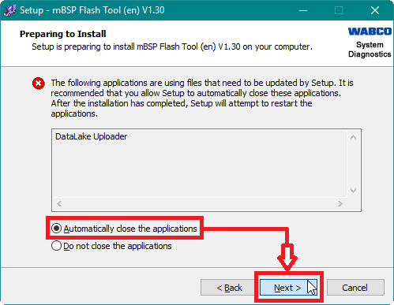

* The setup program will beginning installing the mBSP Flash Tool:

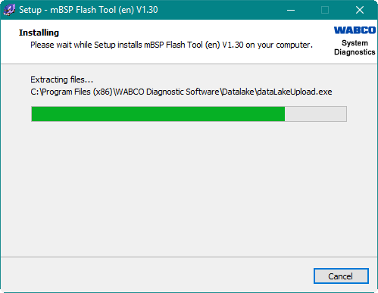

16) At the ‘Welcome to the WABCO USB devices Setup Wizard’ window, click <NEXT>:

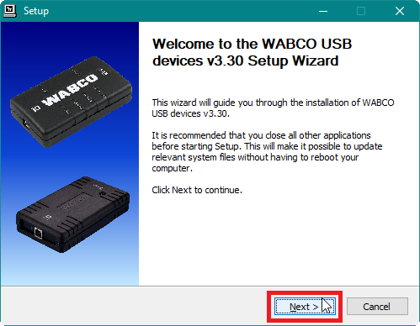

17) At the ‘Choose Install Location’ window, click <INSTALL>:

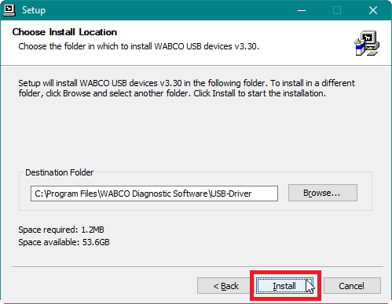

* The Setup program will begin installing files to your local hard drive:

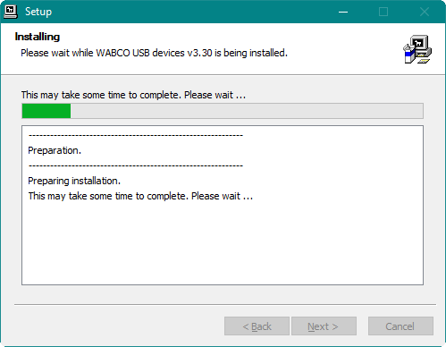

18) At the ‘Installation Complete’ window, click <NEXT>:

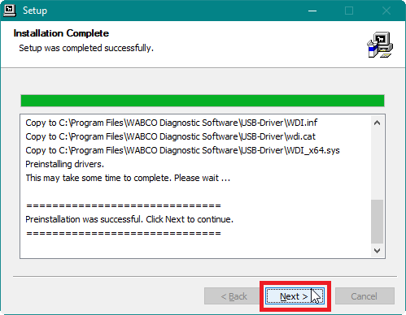

19) At the ‘Completing the WABCO USB devices Setup Wizard’ window, click <FINISH>:

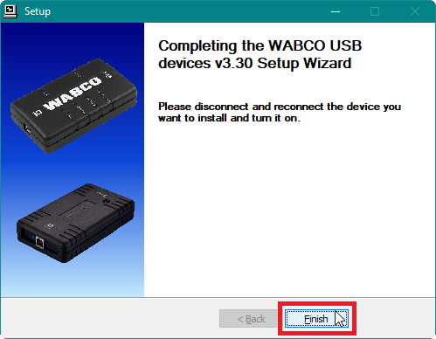

20) At the ‘Setup’ dialog box, click <YES>:

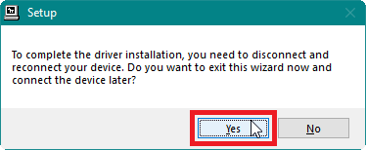

21) At the ‘Completing the mBSP Flash Tool Setup Wizard’ window, click <FINISH>:

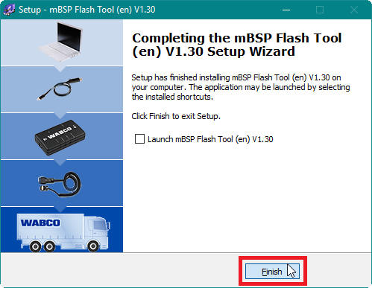

* The ‘mBSP Flash Tool’ can now be launched by double-clicking the ‘mBSP Flash Tool’ icon on your desktop:

