How To Configure Cummins Update Manager To Not Check For Updates During The Flashing Process

1) Click on the Windows Start Menu, type ‘cummins’ and then select ‘Cummins Update Manager’ if it exists and then click ‘Open’ on the right hand side beneath ‘Cummins Update Manager’:

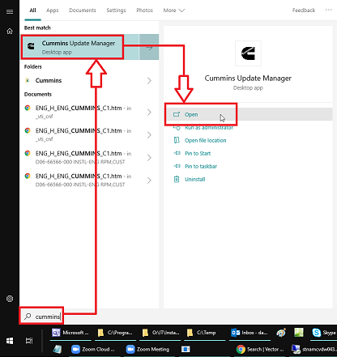

* If ‘Cummins Update Manager’ does not show up when you click on the Windows Start Menu and then type ‘cummins’, then it is not installed on the computer and you can close these instructions.

3) At the ‘Cummins Inc. Update Manager’ program window, click on the ‘Options’ tab in the upper right-hand corner:

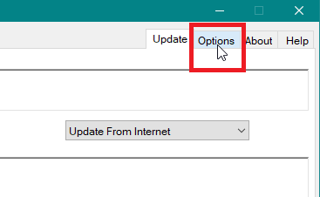

4)

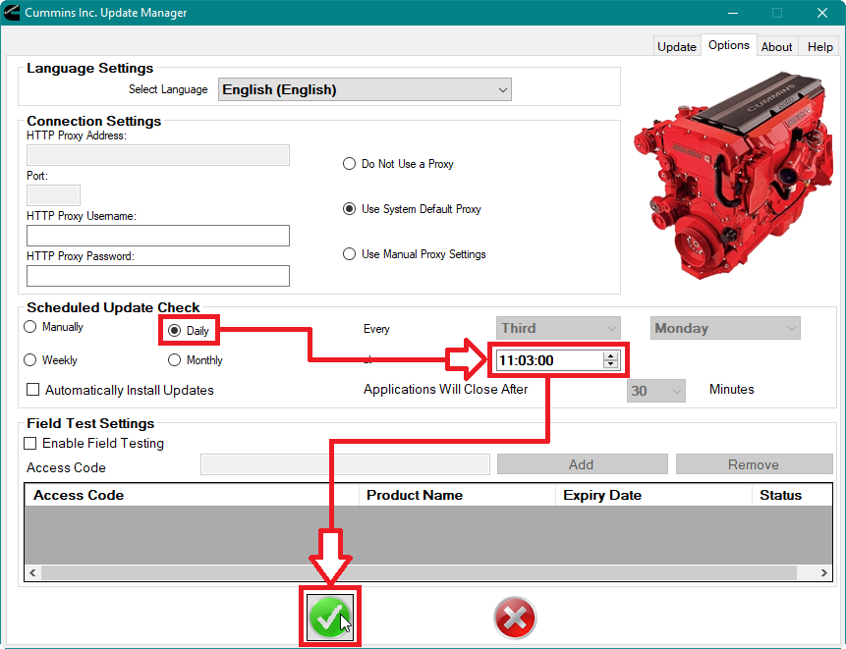

5)

